Batch: B2 Roll No.: 16010121200

Experiment / assignment / tutorial No. 3

TITLE: Study of Umbrello, a Unified Modelling Language tool

AIM: To understand the importance of a common language used by various developers and practitioners for planning and coding. ______________________________________________________________________
Expected Course outcome of Experiment:

Learn Umbrello, the tool, used to create diagrams of software and other systems in the industry-standard UML format.
_____________________________________________________________________
Books/ Journals/ Websites referred:

- https://en.freedownloadmanager.org/Windows-PC/Umbrello-FREE.html
_____________________________________________________________________
Pre Lab/ Prior Concepts:

The Unified Modelling Language (UML) is a diagramming language or notation to specify, visualize and document models of Object Oriented software systems. UML is not a development method, that means it does not tell you what to do first and what to do next or how to design your system, but it helps you to visualize your design and communicate with others. UML is controlled by the Object Management Group (OMG) and is the industry standard for graphically describing software.
UML is designed for Object Oriented software design and has limited use for other programming paradigms.
UML is composed of many model elements that represent the different parts of a software system. The UML elements are used to create diagrams, which represent a certain part, or a point of view of the system.
The following types of diagrams are supported by Umbrello UML Modeller:
- Use Case Diagrams show actors (people or other users of the system), use cases (the scenarios when they use the system), and their relationships
- Class Diagrams show classes and the relationships between them
- Sequence Diagrams show objects and a sequence of method calls they make to other objects.
- Collaboration Diagrams show objects and their relationship, putting emphasis on the objects that participate in the message exchange
- State Diagrams show states, state changes and events in an object or a part of the system
- Activity Diagrams show activities and the changes from one activity to another with the events occurring in some part of the system
- Component Diagrams show the high level programming components (such as KParts or Java Beans).
- Deployment Diagrams show the instances of the components and their relationships.
- Entity Relationship Diagrams show data and the relationships and constraints between the data.
The above types of diagrams are drawn by different levels of designers/ coders to understand the product to be developed. They model the system and be used by developers, tester, project managers for various purposes.

The Umbrello software can be downloaded from https://umbrello.kde.org/
Installation steps: https://umbrello.kde.org/installation.php

Post Laboratory Activity:
- Install Umbrello on the desktop
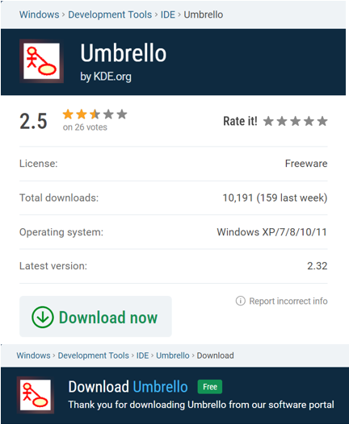

- Study various options and menus, and get acquainted with the IDE.

Umbrello software:
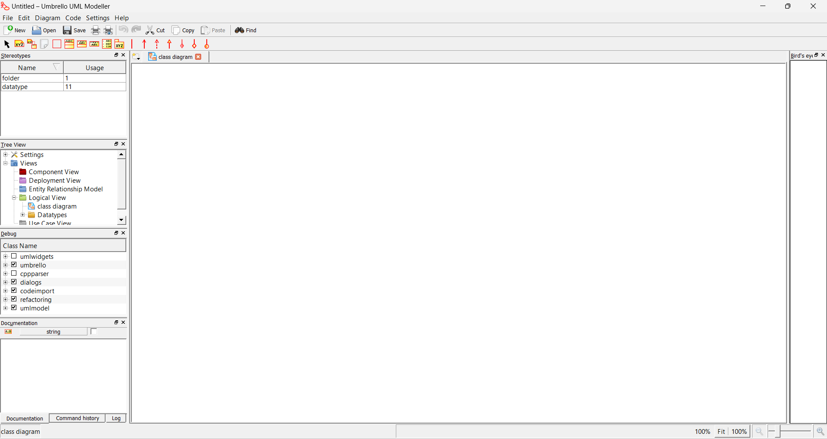

Types of diagrams that could be drawn:
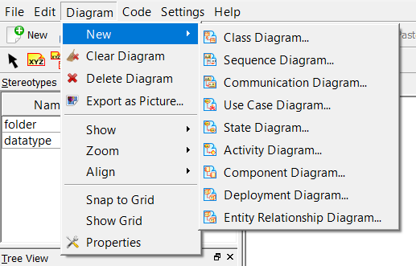

Exploring different options in the various diagrams:
Class Diagram:

Sequence Diagram:

Communication Diagram:

Use Case Diagram:

State Diagram:

Activity Diagram:

Component Diagram:
Deployment Diagram:

Entity Relationship Diagram:

Creating sample Class diagram:
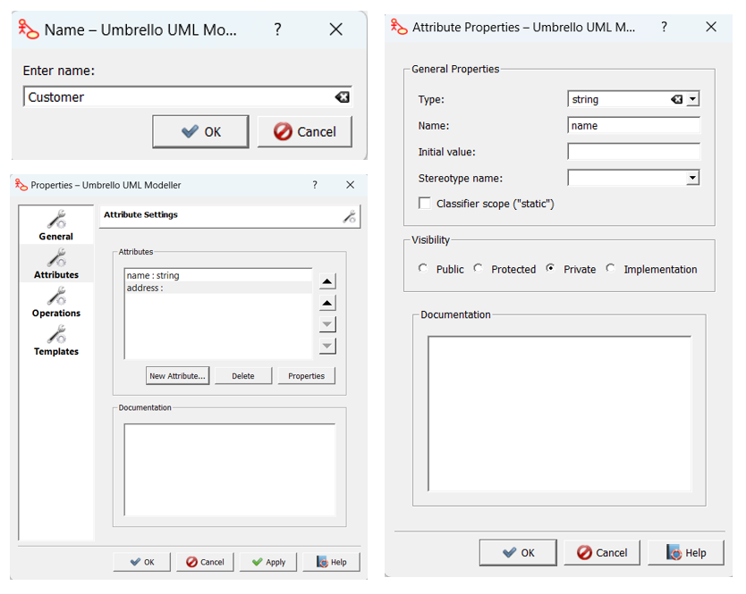
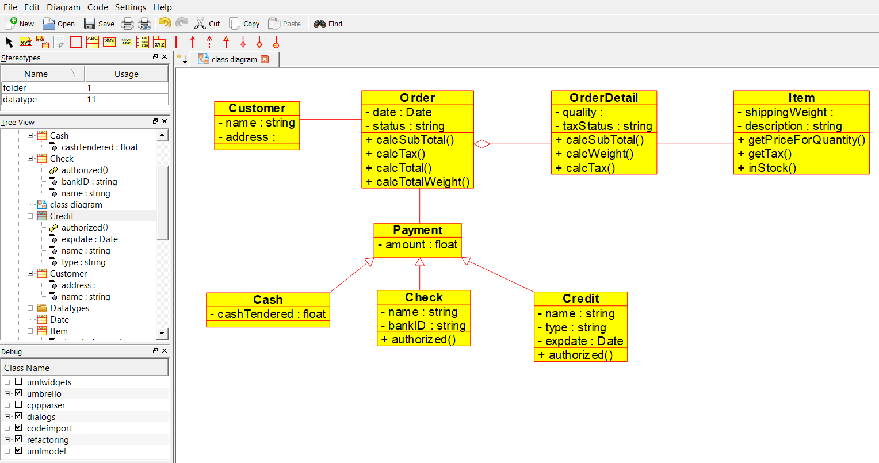
Creating sample Activity Diagram:
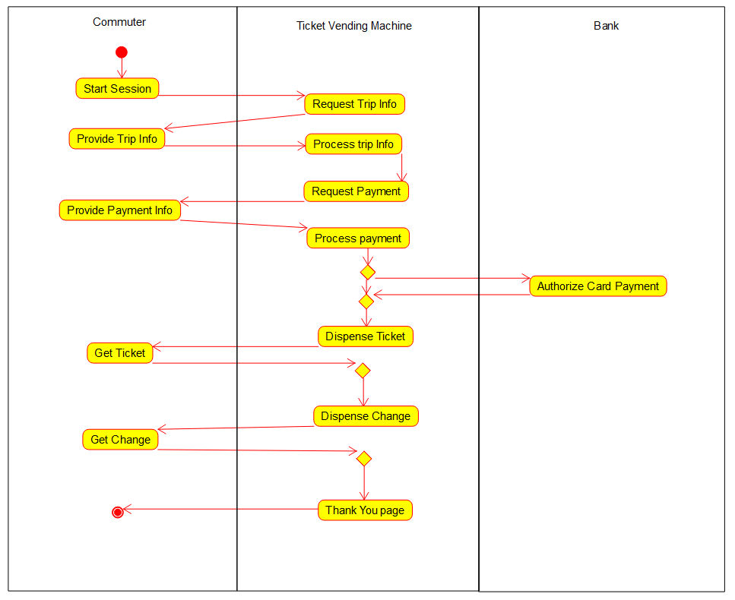

Post Lab Descriptive Questions answers must be handwritten and to be submitted BEFORE the next tern.

  - Why do we need to draw different types of diagrams during software development process?
In addition to the general fact that visuals help people to retain and recall information longer, software system architecture diagrams offer the following benefits:
- Increase understanding: The diagrams provide an overview of the system, so everybody understands how the different components work together when determining what kind of impact updates and new features will have on the system.
- Improve communication: Software architecture diagrams visualize the game plan for everyone—aligning project goals across all teams, departments, and stakeholders. They also keep stakeholders informed of the project’s overall progress.
- Encourage collaboration and identify areas for improvement: Visualizing the application system structure makes it easier for your team members to discuss the design, find patterns that work well, look for weak spots, and find areas to improve in a collaborative effort.
  - List various types of diagrams used in static and dynamic model of a software system.

- Structural Diagrams:
Structural diagrams depict a static view or structure of a system. It is widely used in the documentation of software architecture. It embraces class diagrams, composite structure diagrams, component diagrams, deployment diagrams, object diagrams, and package diagrams. It presents an outline for the system. It stresses the elements to be present that are to be modeled.
- Class Diagram: Class diagrams are one of the most widely used diagrams. It is the backbone of all the object-oriented software systems. It depicts the static structure of the system. It displays the system's class, attributes, and methods. It is helpful in recognizing the relation between different objects as well as classes.
- Composite Structure Diagram: The composite structure diagrams show parts within the class. It displays the relationship between the parts and their configuration that ascertain the behavior of the class. It makes full use of ports, parts, and connectors to portray the internal structure of a structured classifier. It is similar to class diagrams, just the fact it represents individual parts in a detailed manner when compared with class diagrams.
- Object Diagram: It describes the static structure of a system at a particular point in time. It can be used to test the accuracy of class diagrams. It represents distinct instances of classes and the relationship between them at a time.
- Component Diagram: It portrays the organization of the physical components within the system. It is used for modeling execution details. It determines whether the desired functional requirements have been considered by the planned development or not, as it depicts the structural relationships between the elements of a software system.
- Deployment Diagram: It presents the system's software and its hardware by telling what the existing physical components are and what software components are running on them. It produces information about system software. It is incorporated whenever software is used, distributed, or deployed across multiple machines with dissimilar configurations.
- Package Diagram: It is used to illustrate how the packages and their elements are organized. It shows the dependencies between distinct packages. It manages UML diagrams by making it easily understandable. It is used for organizing the class and use case diagrams.
- Behavioural Diagrams:
Behavioural diagrams portray a dynamic view of a system or the behaviour of a system, which describes the functioning of the system. It includes use case diagrams, state diagrams, and activity diagrams. It defines the interaction within the system.
- State Machine Diagram: It is a behavioural diagram. it portrays the system's behaviour utilizing finite state transitions. It is also known as the State-charts diagram. It models the dynamic behaviour of a class in response to external stimuli.
- Activity Diagram: It models the flow of control from one activity to the other. With the help of an activity diagram, we can model sequential and concurrent activities. It visually depicts the workflow as well as what causes an event to occur.
- Use Case Diagram: It represents the functionality of a system by utilizing actors and use cases. It encapsulates the functional requirement of a system and its association with actors. It portrays the use case view of a system.
- Interaction Diagrams:
Interaction diagrams are a subclass of behavioural diagrams that give emphasis to object interactions and also depicts the flow between various use case elements of a system. In simple words, it shows how objects interact with each other and how the data flows within them. It consists of communication, interaction overview, sequence, and timing diagrams.
- Sequence Diagram: It shows the interactions between the objects in terms of messages exchanged over time. It delineates in what order and how the object functions are in a system.
- Communication Diagram: It shows the interchange of sequence messages between the objects. It focuses on objects and their relations. It describes the static and dynamic behaviour of a system.
- Timing Diagram: It is a special kind of sequence diagram used to depict the object's behaviour over a specific period of time. It governs the change in state and object behaviour by showing the time and duration constraints.
- Interaction Overview diagram:
It is a mixture of activity and sequence diagram that depicts a sequence of actions to simplify the complex interactions into simple interactions.

